Make a DRM plugin with NetBeans

Notice :
DRM plugins are locked or unlocked DRM process to read and write CNM data files.

Structure of IDRM (the interface of DRMs) is :

/**
* Initialize the plug-in or confirm it.
*/
public void init();

/**
* A short name for this DRM.
* @return DRM name
*/
public String getName();

/**
* Encrypt your data (which are texts, AAC filenames,...).
* @param data The data to encrypt
* @return Encrypted data
*/
public String encryptData(String data);

/**
* Decrypt your data (which are texts, AAC filenames,...).
* @param data The encrypted data
* @return A readable text
*/
public String decryptData(String data);

/**
* The name of the media concerned by the DRM.
* Example: One Piece Chapter 777, Dragon Ball Chapter 123,...
* @return Media name
*/
public String getMedia();

/**
* The timestamp of the start time and end time can be used for this DRM. (optional)
* @return Usage
* @see ExternalInfo for more informations
*/
public boolean useStartAndEndTime();

/**
* The timestamp of the duration and elapsed time can be used for this DRM. (optional)
* @return Usage
* @see ExternalInfo for more informations
*/
public boolean useDuration();

/**
* The count and total times the file protected by this DRM can be opened. (optional)
* @return Usage
* @see ExternalInfo for more informations
*/
public boolean useCount();

/**
* A boolean value that indicates if we have an external file
* for the total times or for the duration. (optional)
* @return true if an external counter exists otherwise false
* @throws clib.io.drm.DRMException
*/
public boolean hasExternalFile() throws DRMException;

/**
* <p>The filename of the external file if exists. (optional)<br />
* Notice: You have to encrypt this external file.</p>
* @return External counter filename
* @throws clib.io.drm.DRMException
*/
public String getExternalFileName() throws DRMException;

/**
* Encrypt your external data (counter for example and other data like name, MAC address,...).
* @param data The data to encrypt
* @return Encrypted data
* @throws clib.io.drm.DRMException
*/
public String encryptExternal(String data) throws DRMException;

/**
* Decrypt your external data (counter for example and other data like name, MAC address,...).
* @param data The encrypted data
* @return A readable text
* @throws clib.io.drm.DRMException
*/
public String decryptExternal(String data) throws DRMException;

/**
* Encrypt an image
* @param data Data
* @return Encrypted data
*/
public String encryptImage(BufferedImage data);

/**
* Decrypt an image
* @param data The encrypted data
* @return Data
*/
public BufferedImage decryptImage(String data);

/**
* MAC address can protect this DRM. (optional)
* @return Usage
* @see ExternalInfo for more informations
*/
public boolean useMAC();

/**
* First name and last name can protect this DRM. (optional)
* @return Usage
* @see ExternalInfo for more informations
*/
public boolean useFamilyName();

/**
* A password to verify before write an external file.
* @return Password
*/
public String getPassword();

Create a new project and choose « Java Class Library » and name it as you want, like DRMLess.

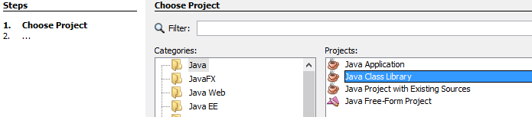

Create a directory called « META-INF/services » inside the source directory.

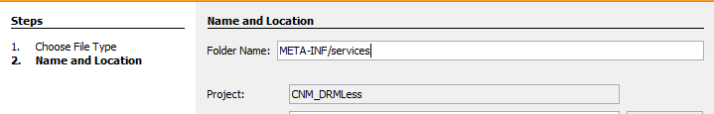

Create a file with the name « clib.io.drm.IDRM ».

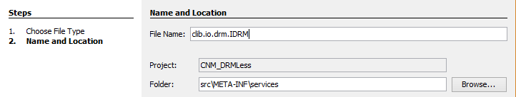

You should have something like that :

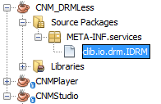

In this file, write a text which contains your choosen name, in my case :
« clib.io.drm.plugins.DRMLess ».

Now create a new directory called « clib/io/drm/plugins » inside the source directory.

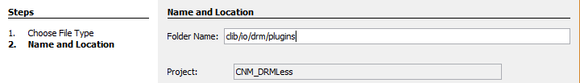

Create a class with the choosen name, in my case DRMLess.

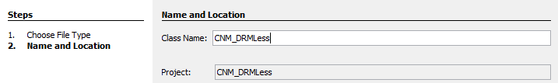

You should now have something like this :

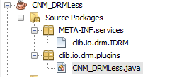

Add now a reference of the main project in the properties :

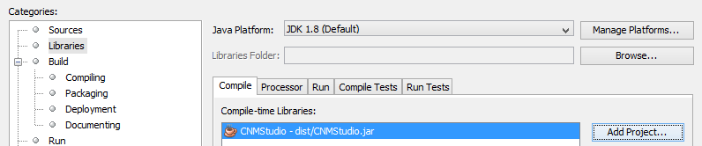

Then write a code like in this example :

package clib.io.drm.plugins;

import clib.io.drm.DRMException;
import clib.io.drm.DRMType;
import clib.io.drm.IDRM;

/**
*
* @author Antoine
*/
public class CNM_DRMLess implements IDRM {

public CNM_DRMLess() {

}

@Override
public void init() {
System.out.println("DRMLess is ready");
}

@Override
public String getName() {
return "DRMLess";
}

@Override
public String encryptData(String data) {
//No encrytion for this free model of DRM (which is not a DRM, lol).
return data;
}

@Override
public String decryptData(String data) {
//No encrytion for this free model of DRM (which is not a DRM, lol).
return data;
}

@Override
public String getMedia() {
//A small hack with a keyword. (Please type your media here, for example One Piece Chapter 777)
return DRMType.Free.toString();
}

@Override
public long getStartTime() throws DRMException {
//A positive number = active
//A negative number = inactive
return -1;
}

@Override
public long getEndTime() throws DRMException {
//A positive number = active
//A negative number = inactive
return -1;
}

@Override
public long getDuration() throws DRMException {
//A positive number = active
//A negative number = inactive
return -1;
}

@Override
public int getCount() throws DRMException {
//A positive number = active
//A negative number = inactive
return -1;
}

@Override
public boolean hasExternalFile() throws DRMException {
return false;
}

@Override
public String getExternalFileName() throws DRMException {
return null;
}

@Override
public String encryptExternal(String data) throws DRMException {
//No encrytion for this free model of DRM (which is not a DRM, lol).
return data;
}

@Override
public String decryptExternal(String data) throws DRMException {
//No encrytion for this free model of DRM (which is not a DRM, lol).
return data;
}
}

And now compress all in a JAR file with a build.
After that you can copy the jar plugin file in the plugins directory of the main project.

